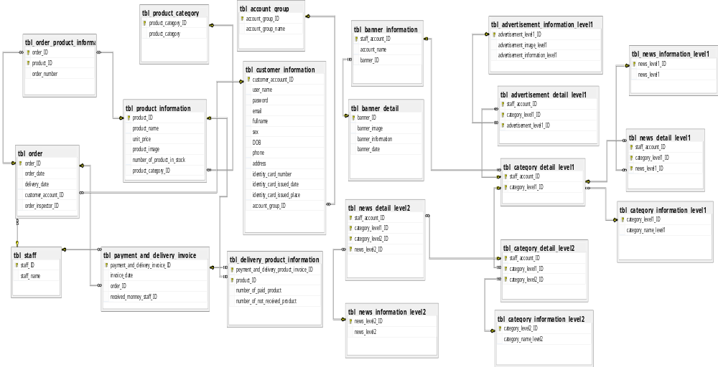

Figure 4.54.Entity Relationship Diagram for “E-Commerce System for NGUYEN DAI DUONG Home Decoration Company”

